

***Insurance Customer Management System***

**Report 3 – Software Requirement Specification**

|  |  |
| --- | --- |
|  | |
| **Group Members** | Lê Thành Long - HE140735  Ngô Quốc Bảo - HE150436  Trần Minh Đức - HE153485  Vũ Linh Đức - HE153739 |
| **Supervisor** | Lecturer: Phạm Ngọc Hà |

**Table of Contents**

I. Project Report **6**

1. Status Report 6

2. Team Involvements 6

3. Issues/Suggestions 6

II. Software Requirement Specification **7**

1. Overall Description 7

1.1 Product Overview 7

1.2 Business Rules 7

2. User Requirements 10

2.1 Overview 10

a. Use Case Diagram 10

Admin 10

Accounter 11

Customer 12

c. Use Cases List 13

2.2 Use Case Specification 15

3. Functional Requirements 46

3.1 System Functional Overview 46

a. Screen Flow 46

b. Screen Details 46

c. Screen Authorization 47

e. Entity Relationship Diagram 49

3.2 Home 50

a. Sign in 50

b. Create Request 51

c. Funtion 53

c1. Forgot Password

c2. Claims

c3. Register

c4. Add Insurance

c5. . Edit Insurance

c6. View Insurance

c7. Update Insurance

c8. Delete Insurance

c9. View Insurance

c10. Add User

c11. Ban User

c12. Edit User

c13. Feedback 65

c14. View Comment and Rating of User

4. Non-Functional Requirements 69

4.1 External Interfaces 69

a. User Interfaces 69

b. Software Interfaces 69

c. Hardware Interfaces 70

d. Communications Interfaces 70

4.2 Quality Attributes 70

a. Usability 70

b. Reliability 71

c. Performance 71

d. Dependability 72

d1. Security 72

d2. Safety 73

e. Supportability 73

f. Design Constraints 73

# I. Project Report

## 1. Status Report

|  |  |  |  |
| --- | --- | --- | --- |
| **#** | **Work Item** | **Status** | **Notes (Work Item in Details)** |
| 1 | Overall Description | Completed |  |
| 2 | User Requirements | Completed |  |
| 3 | Functional Requirements | Completed |  |
| 4 | Non-functional requirements | Completed |  |
| 5 | Other Requirements | Completed |  |

## 2. Team Involvements

|  |  |  |  |
| --- | --- | --- | --- |
| **#** | **Task** | **Member** | **Notes (Task Details, etc.)** |
| 1 | Overall Description |  |  |
| 2 | User Requirements |  |  |
| 3 | Functional Requirements |  |  |
| 4 | Non-functional requirements |  |  |
| 5 | Other Requirements |  |  |

## 3. Issues/Suggestions

|  |  |  |  |
| --- | --- | --- | --- |
| **#** | **Issue** | **Status** | **Notes (Solution, Suggestion, etc.)** |
| 1 |  | Pending |  |
| 2 |  | In Progress |  |
| 3 |  | Completed |  |

# II. Software Requirement Specification

## 1. Overall Description

### 1.1 Product Overview

Currently, life insurance is quite popular all over the world. According to statistics, the number of people buying insurance from 2011 to 2021 ranges from 50% - 60%. Particularly in Vietnam, the proportion of the population participating in life insurance is 7.9% in 2019, this rate is expected to increase to 15.8% by 2025 by the Ministry of Finance. Therefore, the requirement is set as follows: we need a convenient system, good security. So our of company as an insurance company is developing a system to manage their clients and we will help them with that.

.

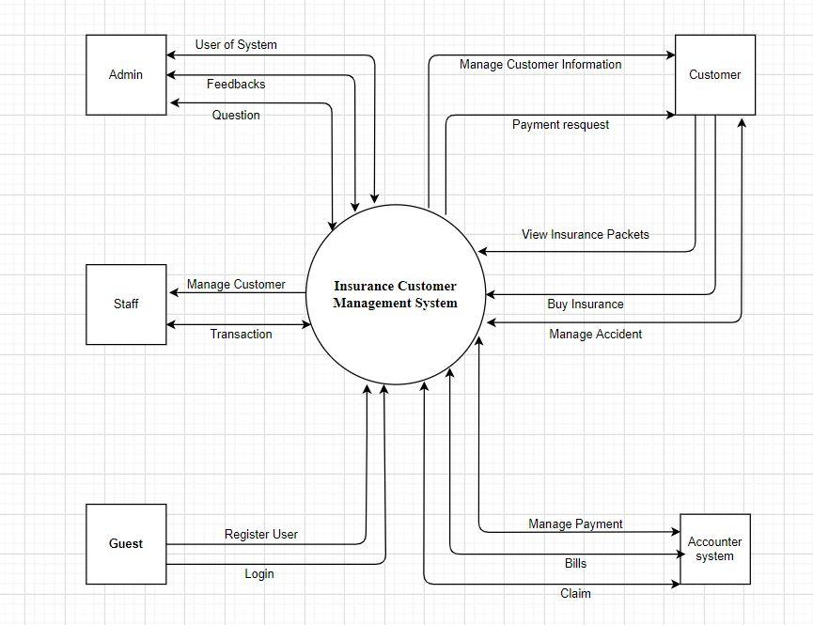.

### 1.2 Business Rules

|  |  |
| --- | --- |
| **No** | **Description** |
| **B01** | Phone number address must be valid |
| **B02** | Phone number cannot be empty |
| **B03** | Phone number must have from 10 digits. |
| **B04** | Each email may be used for only one account. |
| **B05** | After registering, guest must activate their account with the OTP SMS sent to the phone number. |
| **B06** | Password cannot be empty |
| **B07** | Account’s password must be at least 8 characters in length and must contain at least 1 uppercase letter, 1 lower case letter and 1 digit. |
| **B08** | Password must contain at least 8 characters, uppercase of first character, recommend contains the special characters. |
| **B09** | When registering or changing password, user must enter new password twice |
| **B10** | Admin can manage employees, customer and Life insurance package. |
| **B11** | Store manage contract, customer information and life insurance package. |
| **B12** | User must provide their account’s email address and password when logging into the app |
| **B13** | User cannot login to their account unless the account is activated |
| **B14** | Account’s email address must be valid |
| **B15** | When registering or changing password, user must enter new password twice |
| **B16** | A guest must provide their email address and password when registering an account |
| **B17** | User cannot login to their account unless the account is activated |
| **B18** | Customers can find posts without logging in |
| **B19** | User can switch language when that language was supported |
| **B20** | Users can purchase insurance plans but have to log in |
| **B21** | Admin Can post edit, delete posts |
| **B22** | User can't search when the input is blank |
| **B23** | When user reset password, user need the ID user |
| **B24** | Login to access all function in application |
| **B25** | User can contact to employee in app via inbox |
| **B26** | In-app purchase when user want to pay something in app |
| **B27** | Delete the old information and overwrite new information if user want to update |
| **B28** | User update the information via app, then send request to admin |
| **B29** | Admin will validate the information via user’s identity |
| **B30** | Only logged on, customer can chat with staff |

## 2. User Requirements

### 2.1 Overview

#### a. Use Case Diagram

##### Admin

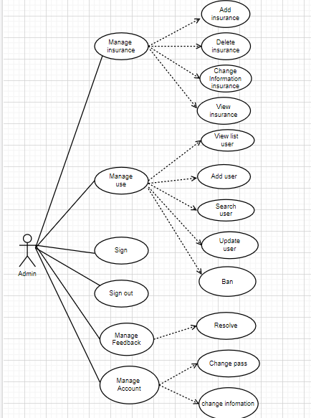

##### Accounter

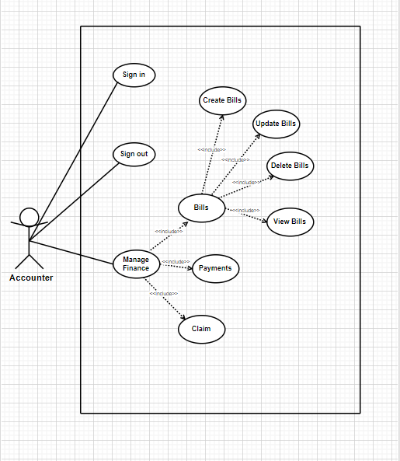

##### Customer

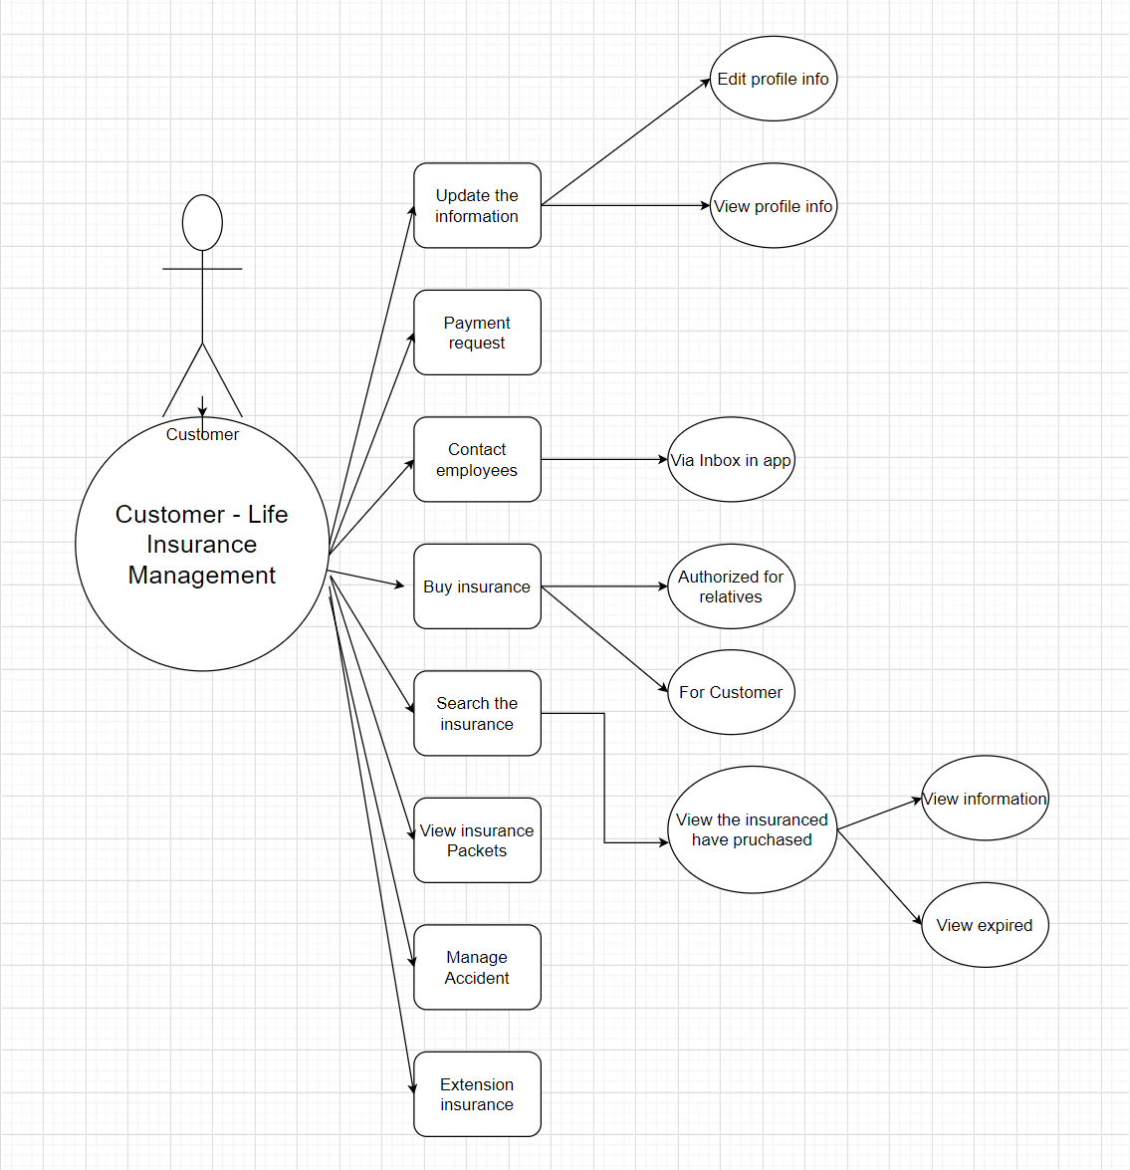

#### b. System Actors

|  |  |  |
| --- | --- | --- |
| **#** | **Actors** | **Description** |
| 1 |  |  |
| 2 |  |  |
| 3 |  |  |
| 4 |  |  |
| 5 |  |  |

#### c. Use Cases List

|  |  |  |  |
| --- | --- | --- | --- |
| **ID** | **Use Case** | **Primary Actors** | **Secondary Actor** |
| UC-1 | Sign In | Accounter | N/A |
| UC-2 | Sign Out | Accounter | N/A |
| UC-3 | View Bill | Accounter | N/A |
| UC-4 | Create Bill | Accounter | N/A |
| UC-5 | Update Bill | Accounter | N/A |
| UC-6 | Delete Bill | Accounter | N/A |
| UC-7 | Payment Method | Accounter | N/A |
| UC-8 | Report Claim | Accounter | N/A |
| UC-9 | Make Claim | Accounter | N/A |
| UC-10 | Search insurance package | Admin | N/A |
| UC-11 | Update insurance package | Admin | N/A |
| UC-12 | Changed Password | Admin | N/A |
| UC-13 | Log in | Admin | N/A |
| UC-14 | Log out | Admin | N/A |
| UC-15 | View list User | Admin | N/A |
| UC-16 | Create User | Admin | N/A |
| UC-17 | Update User | Admin | N/A |
| UC-18 | Search User | Admin | N/A |
| UC-19 | Changed information Admin | Admin | N/A |
| UC-20 | Create an insurance package | Admin | N/A |
| UC-21 | Edit Profile | Staff | N/A |
| UC-22 | Create questions | Staff | N/A |
| UC-23 | Forgot Password | Staff | N/A |
| UC-24 | Register | Staff | N/A |
| UC-25 | Sign in | Staff | N/A |
| UC-26 | Sign out | Staff | N/A |
| UC-27 | Edit profile info | Customer | N/A |
| UC-28 | View profile info | Customer | N/A |
| UC-29 | Payment request | Customer | N/A |
| UC-30 | Contact employees via app | Customer | N/A |
| UC-31 | Buy insurance authorized for relatives | Customer | N/A |
| UC-32 | View expired of purchased insuranced | Customer | N/A |
| UC-33 | View information of purchased insuranced | Customer | N/A |
| UC-34 | Search Insurance | Customer | N/A |
| UC-35 | View Insurance Packet | Customer | N/A |
| UC-36 | Manage Accident | Customer | N/A |
| UC-37 | Extension insurance | Customer | N/A |
| UC-38 | Sign In | Customer | N/A |
| UC-39 | Sign Out | Customer | N/A |
| UC-40 | Register Authorized | Customer | N/A |

### 2.2 Use Case Specification

|  |  |  |  |
| --- | --- | --- | --- |
| **Use Case ID** | UC-2 | **Use Case Name** | Sign Out |
| **Created By** | Lê Thành Long | **Created By** |  |
| **Primary Actor** | Accounter | **Secondary Actor** | N/A |
| **Description** | Accounter sign out the system. | | |
| **Pre-conditions** | 1. Accounter accesses to the system.  2. The Accounter is currently signed in. | | |
| **Post-conditions** | The Accounter is signed out of the system. | | |
| **Normal Flow** | 1. On the home page screen, select the menu with the three-title icon in the upper right corner.  2. Accounter clicks “Sign out”.  3. The system will redirect Accounter to the Home page. | | |
| **Alternative Flow** | N/A | | |
| **Exceptions** | N/A | | |
| **Priority** | High | | |
| **Frequency of Use** | High | | |
| **Business Rules** |  | | |
| **Other information** | N/A | | |
| **Assumptions** | N/A | | |

|  |  |  |  |
| --- | --- | --- | --- |
| **Use Case ID** | UC-3 | **Use Case Name** | View Bill |
| **Created By** | Lê Thành Long | **Created By** |  |
| **Primary Actor** | Accounter | **Secondary Actor** | N/A |
| **Description** | View bill information. | | |
| **Pre-conditions** | Accounter has signed into the account website. | | |
| **Post-conditions** | Show general information of the bill. | | |
| **Normal Flow** | 1. On page screen dashboard of accounter.  2. Accounter click to “Manage Bill”.  3. The system displays all the information the bill in the system | | |
| **Alternative Flow** | N/A | | |
| **Exceptions** | The system displays an error message when:  1. Cannot connect to the server. | | |
| **Priority** | High | | |
| **Frequency of Use** | High | | |
| **Business Rules** |  | | |
| **Other information** | N/A | | |
| **Assumptions** | N/A | | |

|  |  |  |  |
| --- | --- | --- | --- |
| **Use Case ID** | UC-4 | **Use Case Name** | Create Bill |
| **Created By** | Lê Thành Long | **Created By** |  |
| **Primary Actor** | Accounter | **Secondary Actor** | N/A |
| **Description** | Create a bill on the system. | | |
| **Pre-conditions** | 1. Accounter accesses to the system.  2. The Accounter is currently signed in. | | |
| **Post-conditions** | When the normal flow completes successfully, the created bill will be saved into the database with the status “New”. | | |
| **Normal Flow** | 1. On the Accounter home screen.  2. Accounter chooses “New Bill” on the left screen.  3. Input form of a bill.  4. Click “Confirm” button.  5. The system displays a success message.  6. The system redirects to the detail screen of that created request. | | |
| **Alternative Flow** | N/A | | |
| **Exceptions** | The system displays an error message when:  1. Not input identify number, name , dob , adrress , phone number , not choose sex .  2. Cannot connect to the server | | |
| **Priority** | High | | |
| **Frequency of Use** | High | | |
| **Business Rules** |  | | |
| **Other information** | N/A | | |
| **Assumptions** | N/A | | |

|  |  |  |  |
| --- | --- | --- | --- |
| **Use Case ID** | UC-5 | **Use Case Name** | Update Bill |
| **Created By** | Lê Thành Long | **Created By** |  |
| **Primary Actor** | Accounter | **Secondary Actor** | N/A |
| **Description** | Accounter update the bill. | | |
| **Pre-conditions** | 1. Accounter login into System  2. Choose a bill to update | | |
| **Post-conditions** | When the normal flow completes successfully, the bill will be update to success and saved into the database | | |
| **Normal Flow** | 1. On the page screen dashboard of accounter.  2. Mentee click to “List of bill”  3. The system displays lists of all bills created.  4. Accounter choose a bill to edit  5. After that, the accounter clicks the button “Edit”.  6. Accounter click “Save”. | | |
| **Alternative Flow** | 1. On the page screen dashboard of Accounter.  2. Accounter click to “List of bill”  3. The system displays lists of all bills created.  4. Accounter choose a bill to edit  5. After that, the accounter clicks the button “Edit”.  6. Accounter click “Back”.  7. The bill won’t be updated. | | |
| **Exceptions** | The system displays an error message when:  1. Cannot connect to the server | | |
| **Priority** | Medium | | |
| **Frequency of Use** | Medium | | |
| **Business Rules** |  | | |
| **Other information** | N/A | | |
| **Assumptions** | N/A | | |

|  |  |  |  |
| --- | --- | --- | --- |
| **Use Case ID** | UC-6 | **Use Case Name** | Delete Bill |
| **Created By** | Ngô Quốc Bảo | **Created By** |  |
| **Primary Actor** | Accounter | **Secondary Actor** | N/A |
| **Description** | Accounter deletes the bill. | | |
| **Pre-conditions** | 1. The Accounter is currently signed in.  2. Choose a bill to delete. | | |
| **Post-conditions** | When the normal flow completes successfully, the bill will be deleted to success and delete into the database | | |
| **Normal Flow** | 1. On the page screen dashboard of accounter.  2. Mentee click to “List of bill”  3. The system displays lists of all bills created.  4. Accounter choose a bill to delete  5. After that, the accounter clicks the button “Delete”.  6. Accounter click “Confirm”.  7. The system deletes the success bill. | | |
| **Alternative Flow** | 1. On the page screen dashboard of Accounter.  2. Accounter click to “List of bill”  3. The system displays lists of all bills created.  4. Accounter choose a bill to delete  5. After that, the accounter clicks the button “Delete”.  6. Accounter click “Cancel”.  7. The bill won’t be deleted. | | |
| **Exceptions** | The system displays an error message when:  1. Cannot connect to the server | | |
| **Priority** | Medium | | |
| **Frequency of Use** | Medium | | |
| **Business Rules** |  | | |
| **Other information** | N/A | | |
| **Assumptions** | N/A | | |

|  |  |  |  |
| --- | --- | --- | --- |
| **Use Case ID** | UC-7 | **Use Case Name** | Payment Method |
| **Created By** | Ngô Quốc Bảo | **Created By** |  |
| **Primary Actor** | Accounter | **Secondary Actor** | N/A |
| **Description** | Manage transaction invoices. | | |
| **Pre-conditions** | Customer has purchased insurance package. | | |
| **Post-conditions** | When the normal flow completes successfully, the point of Accounter  has updated in the database. | | |
| **Normal Flow** | 1. On the mentee home screen.  2. Choose the tab “Thanh toán” in the sidebar.  3. The system displays form input card payment.  4. Mentee input card information.  5. Click “Thanh toán” button.  6. The system displays the success message. | | |
| **Alternative Flow** | N/A | | |
| **Exceptions** | The system displays an error message when:  1. Cannot connect to the server.  2. Card payment is not correct. | | |
| **Priority** | High | | |
| **Frequency of Use** | Medium | | |
| **Business Rules** |  | | |
| **Other information** | N/A | | |
| **Assumptions** | N/A | | |

|  |  |  |  |
| --- | --- | --- | --- |
| **Use Case ID** | UC-8 | **Use Case Name** | Report Claim |
| **Created By** | Ngô Quốc Bảo | **Created By** |  |
| **Primary Actor** | Accounter | **Secondary Actor** | N/A |
| **Description** | View all requests in the system. | | |
| **Pre-conditions** | 1. Accounter has signed into the admin website.  2. Having at least 1 conflict request on the system. | | |
| **Post-conditions** | When the normal flow completes successfully, the request will be  updated in the database. | | |
| **Normal Flow** | 1. Go to Admin Page  2. Click "Manage Feedback" in the sidebar  3. The system displays all the information of the existing requests in the system  4. Select Report.  5. Send notifications to customers. | | |
| **Alternative Flow** | N/A | | |
| **Exceptions** | The system displays an error message when:  1. Cannot connect to the server. | | |
| **Priority** | High | | |
| **Frequency of Use** | Medium | | |
| **Business Rules** |  | | |
| **Other information** | N/A | | |
| **Assumptions** | N/A | | |

|  |  |  |  |
| --- | --- | --- | --- |
| **Use Case ID** | UC-9 | **Use Case Name** | Make Claim |
| **Created By** | Ngô Quốc Bảo | **Created By** |  |
| **Primary Actor** | Accounter | **Secondary Actor** | N/A |
| **Description** | Feedback for customers. | | |
| **Pre-conditions** | 1. Accounter has signed into the admin website.  2. Response to the complaint has been received | | |
| **Post-conditions** | Notice has been sent to the customer about the complaintbill. | | |
| **Normal Flow** | 1. On page screen dashboard of accounter.  2. Accounter click to “Manage Bill”.  3. The system displays all the information the bill in the system | | |
| **Alternative Flow** | N/A | | |
| **Exceptions** | The system displays an error message when:  1. Cannot connect to the server. | | |
| **Priority** | High | | |
| **Frequency of Use** | High | | |
| **Business Rules** |  | | |
| **Other information** | N/A | | |
| **Assumptions** | N/A | | |

|  |  |  |  |
| --- | --- | --- | --- |
| **Use Case ID** | UC-10 | **Use Case Name** | Search insurance package |
| **Created By** | Ngô Quốc Bảo | **Created By** |  |
| **Primary Actor** | Admin | **Secondary Actor** | N/A |
| **Description** | View all insurance packages in the system.. | | |
| **Pre-conditions** | Admin has signed into the admin website | | |
| **Post-conditions** | N/A. | | |
| **Normal Flow** | 1. Go to the Admin Page.  2. Click the search bar on the toolbar and enter the insurance plan you want to search for.  4. Click the "Search" Button The system will display a list of all insurance packages. | | |
| **Alternative Flow** | N/A | | |
| **Exceptions** | The system displays an error message when:  1. Cannot connect to the server. | | |
| **Priority** | High | | |
| **Frequency of Use** | High | | |
| **Business Rules** |  | | |
| **Other information** | N/A | | |
| **Assumptions** | N/A | | |

|  |  |  |  |
| --- | --- | --- | --- |
| **Use Case ID** | UC-11 | **Use Case Name** | Update insurance package |
| **Created By** | Trần Minh Đức | **Created By** |  |
| **Primary Actor** | Admin | **Secondary Actor** | N/A |
| **Description** | Update existing package coverage. | | |
| **Pre-conditions** | Admin has signed into the admin website. | | |
| **Post-conditions** | When the normal process is completed successfully, the new insurance plan will saved to the database. | | |
| **Normal Flow** | 1. Go to the Admin Page.  2. Click “Manage Insurance” in the sidebar.  3. Click “Edit” button to print 1 insurance package.  4. Update of the insurance package.  5. Click the “Update” button. | | |
| **Alternative Flow** | N/A | | |
| **Exceptions** | The system displays an error message when:  1. Unable to connect to the server.  2. Duplicate insurance packages in the system. | | |
| **Priority** | High | | |
| **Frequency of Use** | High | | |
| **Business Rules** |  | | |
| **Other information** | N/A | | |
| **Assumptions** | N/A | | |

|  |  |  |  |
| --- | --- | --- | --- |
| **Use Case ID** | UC-21 | **Use Case Name** | Edit profile |
| **Created By** | Trần Minh Đức | **Created By** |  |
| **Primary Actor** | Staff | **Secondary Actor** | N/A |
| **Description** | Staff edit profile | | |
| **Pre-conditions** | 1.Staff accesses to the system.  2. The staff is currently signed in. | | |
| **Post-conditions** | The Staff is signed out of the system. | | |
| **Normal Flow** | 1. On the home page screen, select the menu with the three-title icon in the upper right corner.  2. Staff clicks “Edit profile”  3. The system will redirect Staff to the Home page. | | |
| **Alternative Flow** | N/A | | |
| **Exceptions** | N/A | | |
| **Priority** | High | | |
| **Frequency of Use** | High | | |
| **Business Rules** |  | | |
| **Other information** | N/A | | |
| **Assumptions** | N/A | | |

|  |  |  |  |
| --- | --- | --- | --- |
| **Use Case ID** | UC-22 | **Use Case Name** | Create questions |
| **Created By** | Trần Minh Đức | **Created By** |  |
| **Primary Actor** | Staff | **Secondary Actor** | N/A |
| **Description** | Create questions to help customer about problem | | |
| **Pre-conditions** | Staff has signed into the account website. | | |
| **Post-conditions** | Show general information of the questions. | | |
| **Normal Flow** | 1. On page screen dashboard of staff.  2. Staff click to “More”.  3.Staff click to “Create questions”  4.Add information about question of customer.  3. The system displays all the information the question in the system | | |
| **Alternative Flow** | N/A | | |
| **Exceptions** | The system displays an error message when:  1. Cannot connect to the server. | | |
| **Priority** | High | | |
| **Frequency of Use** | High | | |
| **Business Rules** |  | | |
| **Other information** | N/A | | |
| **Assumptions** | N/A | | |

|  |  |  |  |
| --- | --- | --- | --- |
| **Use Case ID** | UC-23 | **Use Case Name** | Forgot Password |
| **Created By** | Trần Minh Đức | **Created By** |  |
| **Primary Actor** | Staff | **Secondary Actor** | N/A |
| **Description** | Change password if customer and staff forgot it. | | |
| **Pre-conditions** | 1. Staff accesses to the system.  2. The Staff is currently signed in. | | |
| **Post-conditions** | Show message “ Can’t connect to system” | | |
| **Normal Flow** | 1. On the Log in home screen.  2. Staff chooses “Forgot Password” on the left screen.  3. Input email or phone number to re-take password.  4. Input new password  5. Click “Confirm” button.  6. The system displays a success message.  7. The system redirects to the detail screen of that created request. | | |
| **Alternative Flow** | N/A | | |
| **Exceptions** | The system displays an error message when:  1. Not input identify phone number, email  2.Password invalid  2. Cannot connect to the server | | |
| **Priority** | High | | |
| **Frequency of Use** | High | | |
| **Business Rules** |  | | |
| **Other information** | N/A | | |
| **Assumptions** | N/A | | |

|  |  |  |  |
| --- | --- | --- | --- |
| **Use Case ID** | UC-24 | **Use Case Name** | Register |
| **Created By** | Trần Minh Đức | **Created By** |  |
| **Primary Actor** | Customer | **Secondary Actor** | N/A |
| **Description** | Customer register new account | | |
| **Pre-conditions** | 1. Customer go into System | | |
| **Post-conditions** | Home screen will show message “Do you have an account !” | | |
| **Normal Flow** | 1. On the page screen dashboard of customer.  2. Customer click to “Register”  3. The system displays information about register.  4. Customer fill all information profile  5. After that, the customer clicks the button “OK”.  6. Show message “Register success !” | | |
| **Alternative Flow** | N/A | | |
| **Exceptions** | The system displays an error message when:   1. Cannot connect to the server 2. Check invalid | | |
| **Priority** | Medium | | |
| **Frequency of Use** | Medium | | |
| **Business Rules** |  | | |
| **Other information** | N/A | | |
| **Assumptions** | N/A | | |

|  |  |  |  |
| --- | --- | --- | --- |
| **Use Case ID** | UC-25 | **Use Case Name** | Sign in |
| **Created By** | Vũ Linh Đức | **Created By** |  |
| **Primary Actor** | Customer | **Secondary Actor** | N/A |
| **Description** | Sign in to System | | |
| **Pre-conditions** | 1. The customer is currently signed in. | | |
| **Post-conditions** | When sign in success, go to home screen | | |
| **Normal Flow** | 1. On the page screen  2. Customer click to “Sign in”  3. The system displays account and password.  4. Customer fill account and password  5. After that, the customer clicks the button “Ok”.  6. The system show message ”Sign in success ! ” | | |
| **Alternative Flow** | N/A | | |
| **Exceptions** | The system displays an error message when:   1. Cannot connect to the server 2. Account or password invalid | | |
| **Priority** | Medium | | |
| **Frequency of Use** | Medium | | |
| **Business Rules** |  | | |
| **Other information** | N/A | | |
| **Assumptions** | N/A | | |

|  |  |  |  |
| --- | --- | --- | --- |
| **Use Case ID** | UC-27 | | |
| **Use Case Name** | Edit profile info | | |
| **Creator** | Vũ Linh Đức | **Date Created** |  |
| **Version** | 1.0 | **Last Updated** |  |
| **Actor** | Edit | **Secondary Actors** | N/A |
| **Description** | Edit and update the customer’s info | | |
| **Pre-conditions** | - User login into the app  - User input the password before edit and update | | |
| **Post-conditions** | - The information of customer is update to system  - System redirect to updated information | | |
| **Normal Flow** | **1. From the homepage, customer clicks on button "Profile info”** **2. The system will load the Customer’s profile.** **3. On the left side of the website have a slide bar which display list store.** **Admin click “Edit info” to update contract. System display the info editor** **4. Admin find the component to update** **5. Admin click “Finish” icon** **6. System load update page**  **7. System display messenger ”Do you want update information”** **8. System redirect to** updated information **page. User** **update success.** | | |
| **Alternative Flows** | N/A | | |
| **Exceptions** | If any required fields is empty, the message box “Required fields cannot be blank” will appear | | |
| **Priority** | Medium | | |
| **Frequency of Use** | High | | |
| **Business Rules** | BR-11, BR-14 | | |
| **Other Information** | N/A | | |

|  |  |  |  |
| --- | --- | --- | --- |
| **Use Case ID** | UC-29 | | |
| **Use Case Name** | Payment request | | |
| **Creator** | Vũ Linh Đức | **Date Created** |  |
| **Version** | 1.0 | **Last Updated** |  |
| **Actor** | Edit | **Secondary Actors** | N/A |
| **Description** | Payment for purchase or extend the life insurance via payment method like Internet Banking, Bank account, … | | |
| **Pre-conditions** | - User login into the app  - User input the password before purchase | | |
| **Post-conditions** | - Use payment method to buy or extend the insurance | | |
| **Normal Flow** | - Link the account to the bank account if customer use the Bank account method | | |
| **Alternative Flows** | N/A | | |
| **Exceptions** | - If any required fields is empty, the message box “Required fields cannot be blank” will appear  - If the information of payment wrong, the message box “Check the payment information” will appear | | |
| **Priority** | High | | |
| **Frequency of Use** | High | | |
| **Business Rules** | BR-05, BR-17, BR-26 | | |
| **Other Information** | N/A | | |

|  |  |  |  |
| --- | --- | --- | --- |
| **Use Case ID** | UC-37 | | |
| **Use Case Name** | Extension insurance | | |
| **Creator** | Vũ Linh Đức | **Date Created** |  |
| **Version** | 1.0 | **Last Updated** |  |
| **Actor** | Edit | **Secondary Actors** | N/A |
| **Description** | Use payment method to extend the insurance | | |
| **Pre-conditions** | - User login into the app  - User input the password before purchase | | |
| **Post-conditions** | - Use payment method to extend the insurance | | |
| **Normal Flow** | **1. From the homepage, customer clicks on button "Buy or extend”** **2. The system will load the Buy or extension page.** **3. Choose the “life insuarance methods”**  **4. Choose time to extend**  **5. Choose the insuarance want to extend**  6. Click “finish” icon **7. System load payment page**  8. Choose payment method **9. Input the required information then click “Pay”**  **10. Input the password**  **11. System redirect to payment success page. The insurance extended.** | | |
| **Alternative Flows** | N/A | | |
| **Exceptions** | - If any required fields is empty, the message box “Required fields cannot be blank” will appear  - If the information of payment wrong, the message box “Check the payment information” will appear | | |
| **Priority** | High | | |
| **Frequency of Use** | High | | |
| **Business Rules** | BR-05, BR-17, BR-26 | | |
| **Other Information** | N/A | | |

|  |  |  |  |
| --- | --- | --- | --- |
| **Use Case ID** | UC-36 | | |
| **Use Case Name** | Manage accident | | |
| **Creator** | Vũ Linh Đức | **Date Created** |  |
| **Version** | 1.0 | **Last Updated** |  |
| **Actor** | Edit | **Secondary Actors** | N/A |
| **Description** | - View the customer’s accident list | | |
| **Pre-conditions** | - User login into the app  - User input the password before view | | |
| **Post-conditions** | - System direct to loading the list | | |
| **Normal Flow** | **1. From the homepage, customer clicks on button "Manage accident”** **2. The system will load the Accident list.** | | |
| **Alternative Flows** | N/A | | |
| **Exceptions** | N/A | | |
| **Priority** | Medium | | |
| **Frequency of Use** | Medium-high | | |
| **Business Rules** | BR-22 | | |
| **Other Information** | N/A | | |

|  |  |  |  |
| --- | --- | --- | --- |
| **Use Case ID** | UC-30 | | |
| **Use Case Name** | Contact employees via app | | |
| **Creator** | Vũ Linh Đức | **Date Created** |  |
| **Version** | 1.0 | **Last Updated** |  |
| **Actor** | Edit | **Secondary Actors** | N/A |
| **Description** | - Contact to staff if customer have any troubleshoot | | |
| **Pre-conditions** | - User login into the app  - User input the password before contact | | |
| **Post-conditions** | - The app will link to database to send the contact request to any staff | | |
| **Normal Flow** | **1. From the homepage, customer clicks on button "Contact staff”** **2. The system will load the Contact staff page.** **3. Choose the contact method** **4. Wait a second to connect with staff** | | |
| **Alternative Flows** | N/A | | |
| **Exceptions** | - If any staff busy, the app will notice try to call later | | |
| **Priority** | High | | |
| **Frequency of Use** | High | | |
| **Business Rules** | BR-25 | | |
| **Other Information** | N/A | | |

## 3. Functional Requirements

### 3.1 System Functional Overview

#### a. Screen Flow

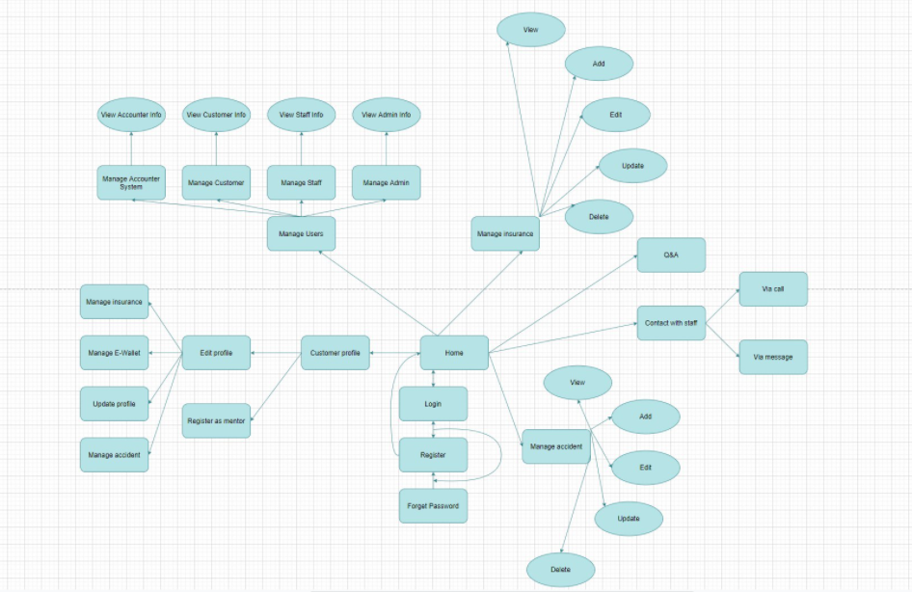

#### b. Screen Details

|  |  |  |  |
| --- | --- | --- | --- |
| # | **Feature** | **Screen** | **Description** |
| 1 | Home | Sign In | Screen for the user to sign in into the system. |
| 2 | Home | Register | Screen for guests to create an account. |
| 3 | Home | Forgot Password | Screen for the user to find the password. |
| 4 | Customer Profile | Home | Display screen: insurance management, account information |
| 5 | Customer Profile | User Profile | The screen shows useful information. |
| 6 | Customer Profile | Edit Profile | The screen where users edit their profiles |
| 7 | Customer Profile | Sign Out | Screen for the user to log out of the system. |
| 8 | Customer Profile | View Insurance | Screen for the user to view the insurance. |
| 9 | Insurance Manage | Edit Insurance | The screen where Admin edit insurance. |
| 10 | Insurance Manage | Add Insurance | The screen where admin adds insurance. |
| 11 | Insurance Manage | Update Insurance | The screen where admin updates insurance. |
| 12 | Insurance Manage | Delete Insurance | The screen where admin deletes insurance. |
| 13 | Insurance Manage | View Insurance | The screen where Staff and admin view all insurance |
| 14 | Manage user | Add user | The screen where Admin adds new users. |
| 15 | Manage user | Edit information user | The screen where Admin edit users. |
| 16 | Manage user | Ban user | The screen where Admin bans users. |
| 17 | Manage Accident | View accident | The screen where Admin and staff view the user insurance plans that have been passed away. |
| 18 | Q&A | View questions | The screen Admin and Staff views all the questions. |
| 19 | Q&A | Feedback for customer | The screen Admin and Staff answer all the questions. |
| 20 | Contact with Staff | Call Video/Audio | Video/audio pop-up for staff with staff |
| 21 | Contact with Staff | Chat Box | Chat Box The popup chat box for staff with staff |
| 22 | Contact with Staff | Chat Box  with Customer | Chat Box The popup chat box for staff with customer |
|  |  |  |  |

#### c. Screen Authorization

|  |  |  |  |
| --- | --- | --- | --- |
| Screen | Admin | Staff | Customer |
| **Home** | X | X | X |
| Sign in | X | X | X |
| Register |  |  | X |
| Forgot Password |  | X | X |
| **Profile** | X | X | X |
| Home | X | X | X |
| Edit Profile | X | X | X |
| View Insurance | X | X | X |
| Create Insurance | X |  |  |
| Edit Insurance | X |  |  |
| Delete Insurance | X |  |  |
| Sign Out | X | X | X |
| Manage E-Wallet |  |  | X |
| **Manage User** | X |  |  |
| Edit information user | X | X | X |
| Ban user |  | X | X |
| Add user |  | X | X |
| **Q&A** |  |  | X |
| View Feedback | X | X |  |
| Feedback |  |  | X |
| Respond |  | X |  |
| **Contact with Staff** | X | X | X |
| Chat | X | X | X |
| Call Video | X | X |  |
| Chat Box with Customer |  | X |  |

#### d. Non-Screen Functions

|  |  |  |  |
| --- | --- | --- | --- |
| **#** | **Feature** | **System Function** | **Description** |
| 1 |  |  |  |

#### e. Entity Relationship Diagram

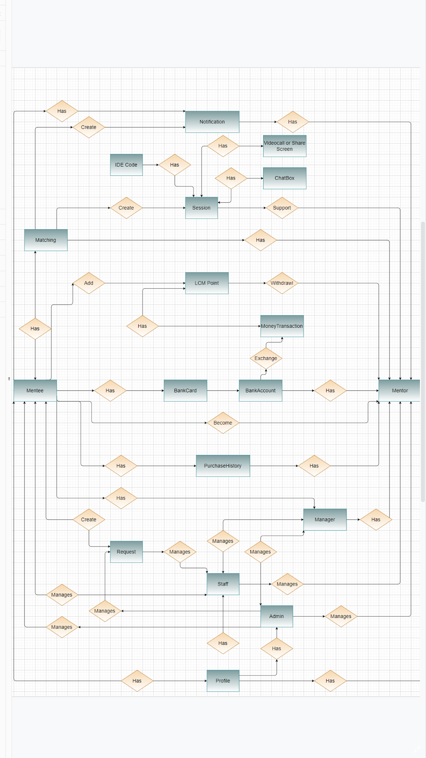

**Entities List**

|  |  |  |
| --- | --- | --- |
| **#** | **Entity** | **Description** |
|  |  |  |
|  |  |  |
|  |  |  |
|  |  |  |
|  |  |  |
|  |  |  |
|  |  |  |
|  |  |  |
|  |  |  |
|  |  |  |
|  |  |  |
|  |  |  |
|  |  |  |
|  |  |  |
|  |  |  |
|  |  |  |
|  |  |  |
|  |  |  |
|  |  |  |

### 3.2 Home

**a. Sign in**

● Function trigger: This function is triggered when the user clicks Sign in from Homepage

● Function description: User sign in into the system.

● Screen layout: mock-up prototype of the screen, sample below is for the Sign in screen.

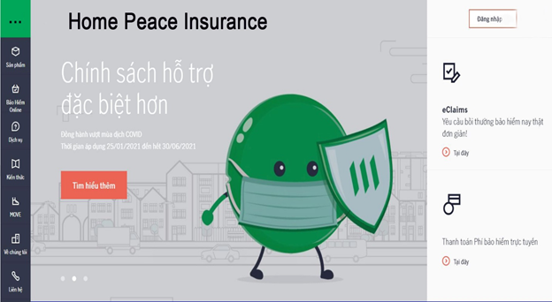

Figure 3.9: Home

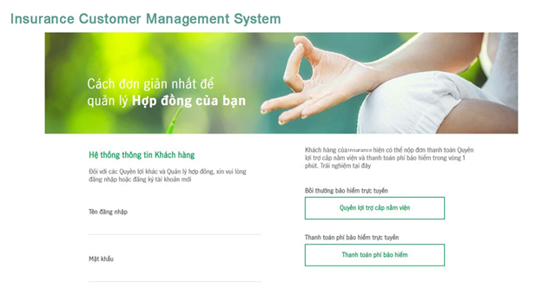

Figure 4.0: Login Mock-up

**b. Create Request**

● Function trigger: This function is triggered when the mentee clicks Create Request from the Homepage.

● Function description: The mentee created a question to ask the mentor.

● Screen layout: mock up a prototype of the screen, the sample below is for the Create Request

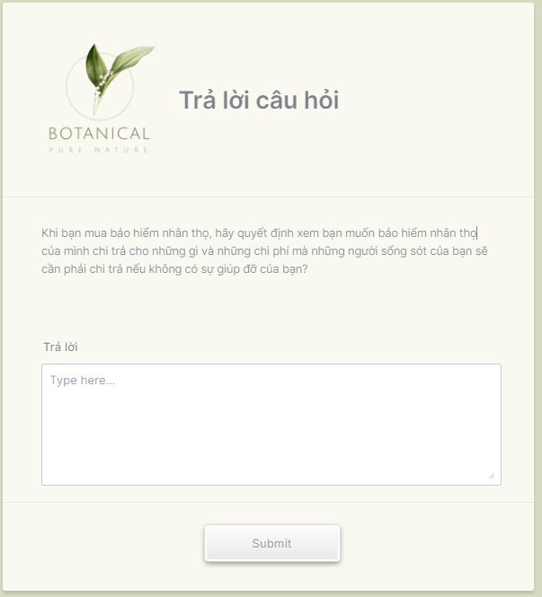

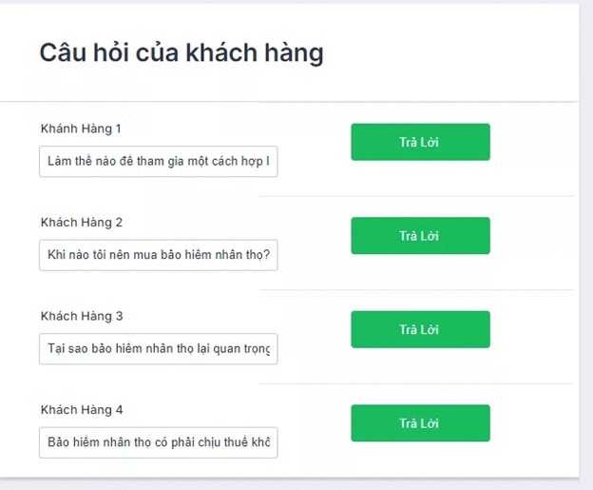

**c. Function**

**1. Forgot Password**

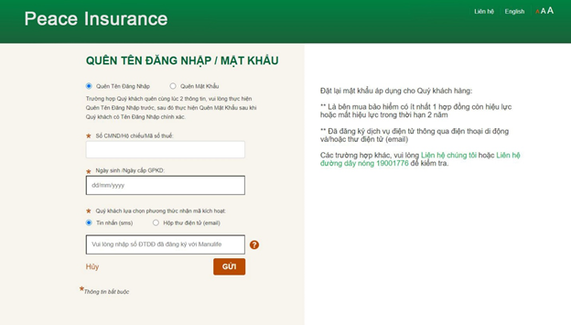

4.1 Forgot Password

**2. Claims**

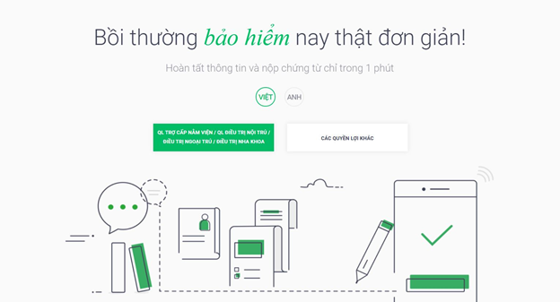

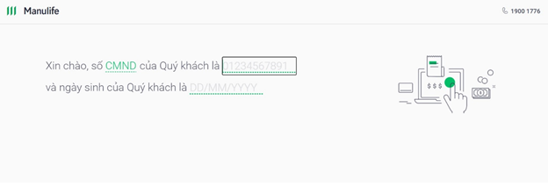

4.2 Claims

**3. Register**

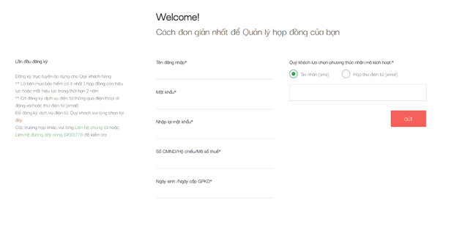

4.3 Register

**4. Add Insurance**

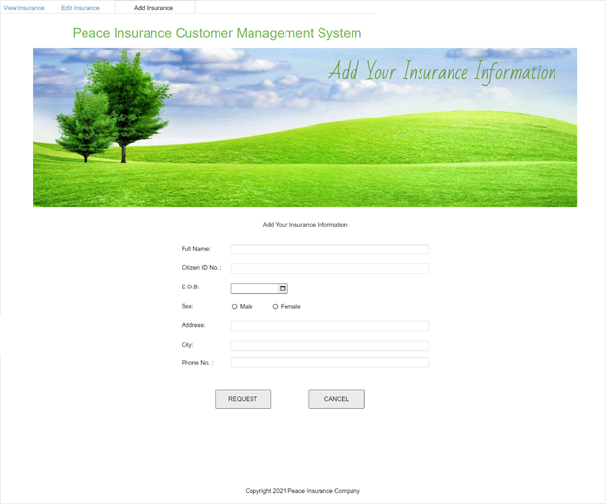

4.4 Add Insurance

**5. Edit Insurance**

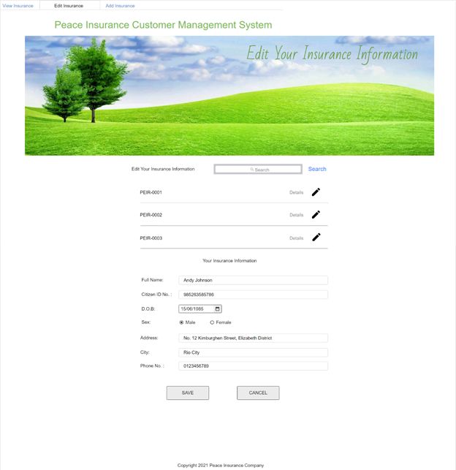

4.5 Edit Insurance

**6. View Insurance**

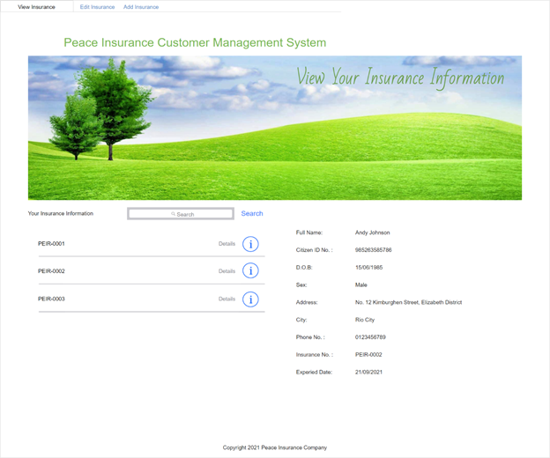

4.6 View Insurance

**7. Update Insurance**

● Function trigger: This function is triggered when the user clicks Update Insurance from the Homepage.

● Function description: The user update new information for insurance’s owner.

● Screen layout: mock up a prototype of the screen, the sample below is for the Insurance Customization

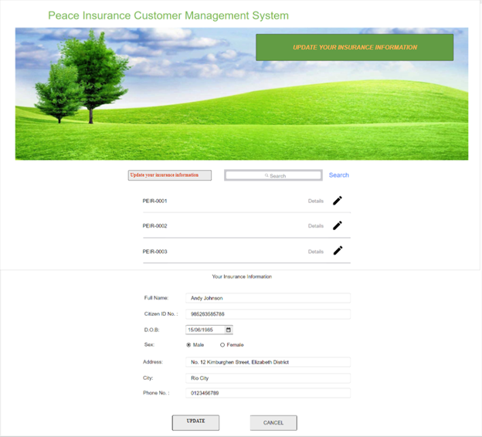

4.7. Update Insurance

**8. Delete Insurance**

● Function trigger: This function is triggered when the user clicks Delete Insurance from the Homepage.

● Function description: The user delete the insurance they want.

● Screen layout: mock up a prototype of the screen, the sample below is for the Insurance Customization

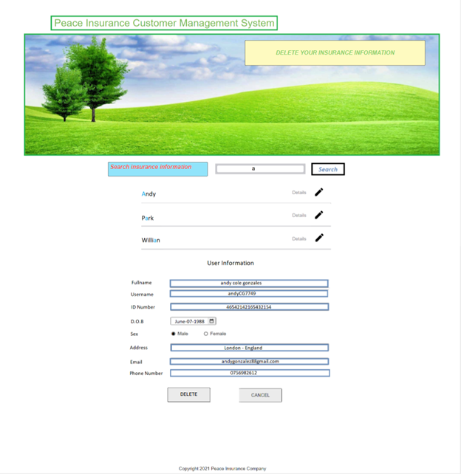

4.8 Delete Insurance

**9. View Insurance**

● Function trigger: This function is triggered when the user clicks View Insurance from the Homepage.

● Function description: The user view all insurance they owned.

● Screen layout: mock up a prototype of the screen, the sample below is for the Insurance Customization

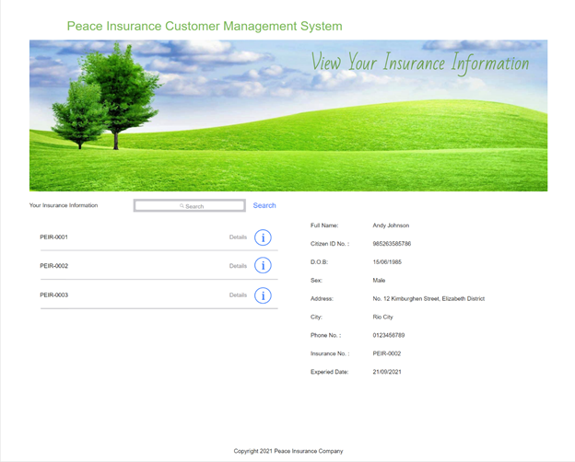

4.9. View Insurance

**10.Add User**

● Function trigger: This function is triggered when the staff Add User from the Homepage.

● Function description: The staff add new user to the system.

● Screen layout: mock up a prototype of the screen, the sample below is for the Add new User.

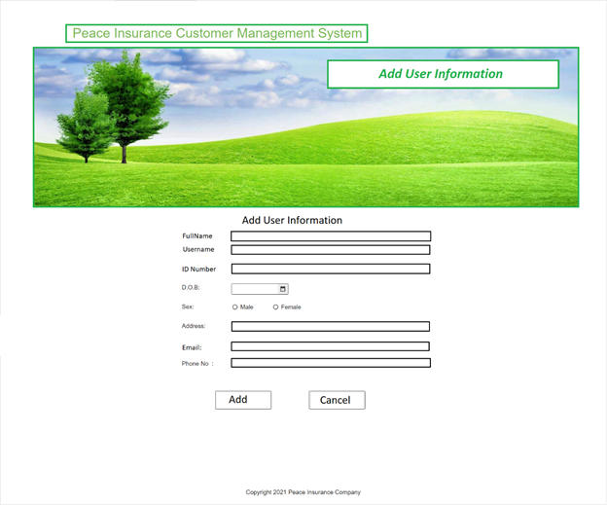

4.10 Add User

**11. Ban User**

● Function trigger: This function is triggered when the staff clicks Ban User from the Homepage.

● Function description: The staff ban user out of the system.

● Screen layout: mock up a prototype of the screen, the sample below is for the Ban User

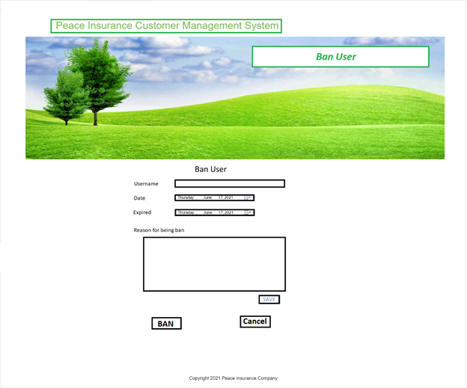

4.11 Ban User

**12. Edit User**

● Function trigger: This function is triggered when the staff clicks Edit User from the Homepage.

● Function description: The staff edit user personal information.

● Screen layout: mock up a prototype of the screen, the sample below is for the Edit User

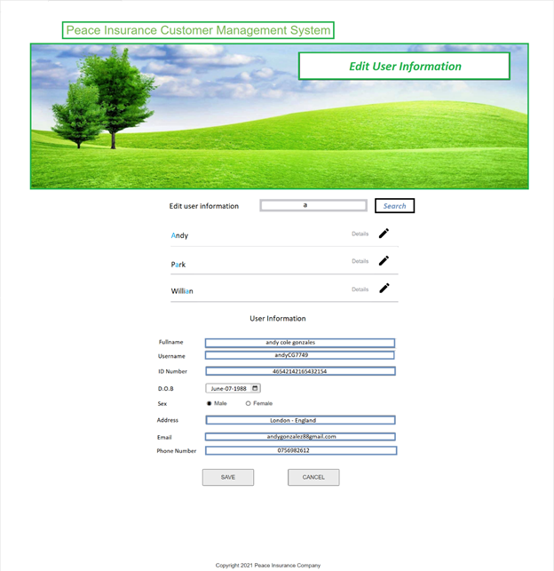

4.12 Edit User

**13. Feedback**

● Activate function: This function is activated when customer login

● Function Description: Customers send questions to users

● Screen layout: There are fields to fill in information and places to fill in questions you want to answer

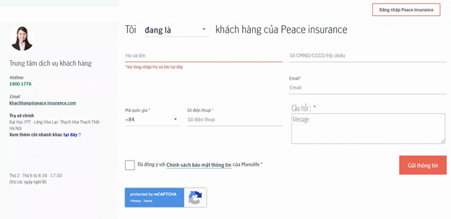

4.13 Feedback

#### 14. View Comment and Rating of User

* *Function trigger: This function is triggered user view Profile CV of Mentor*
* *Function description: The user and guest can view rating and comment of men*
* *Screen layout: mock-up prototype of the screen, sample below is for the View Rating and Comment of Mentor.*

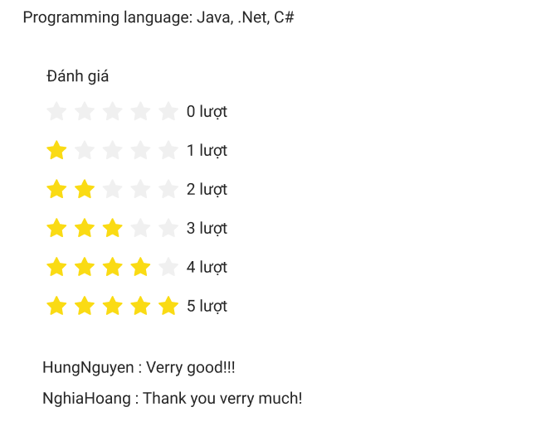

* *Function Details: Guest and users can see the comment and rating of the mentor.*

**4. Non-Functional Requirements**

**4.1 External Interfaces**

**a. User Interfaces**

UI-1: The websites will have a user-friendly interface and are easy to use.

UI-2: The layout of the screen is streamlined, easy to operate, and implement for the user.

UI-3: Buttons have distinctive features and colors but are in sync with the interface.

UI-4: When the user is on a screen or function, the position of that function displayed on the sidebar will be bright and synchronized with the interface.

UI-5: Notifications displayed on the screen have a friendly banner outlining the content for the user.

UI-6: The LCM screen displays shall conform to the Process Impact Internet Application User Interface Standard, Version 2.0 [3].

UI-7: The system will provide a website help link that is displayed explaining how to use that page to the user.

UI-8: Web pages will allow users to copy and paste using a mouse, in addition to using a mouse and keyboard combination.

**b. Software Interfaces**

SI-1: Login System

SI-1.1: The system will pass the username and password of the user to the sign in system through a programming interface

SI-1.2: The sign-in system will notify that the user exists or not

SI-1.3: When the sign-in system notifies that the user exists or does not exist, ISM will take user to the homepage or send a notification that the user does not exist

SI-2: Manage system

The LCM shall communicate with the Manage System through a programmatic interface for the following operations:

SI-2.1: To allow an Admin to view all Users.

SI-2.2: To allow an Admin to view all Employees.

SI-2.3: To allow an Admin to view all Requests.

SI-2.4: To allow an Admin to view all Insurances.

SI-2.5: To inquire whether an Admin do some action in system.

SI-3: Payment system

SI-3.1: The Payment system will allow users to pay if user extension or buy insurance

SI-3.2: After payment, the new insurance will updated or the insurance existed yet will updated new expired.

**c. Hardware Interfaces**

No hardware interfaces have been identified.

**d. Communication Interface**

CI-1: System will send an email or text message to.Register phone number or gmail.

CI-2: The system provides people and employees with a chat box to communicate.

**4.2 Quality Attributes**

**a. Usability**

● Language is Vietnamese and English subject to change.

● User interface should be elegant, easy to navigate and friendly and easy to use

● All function titles or names must be easy to understand and purposeful

● All error messages must be clear to all users

● All account-related functions are arranged and placed in the navigation bar and have a clear purpose

● Clear and recognizable, clickable links and buttons.

● The main functions are organized into tabs on the toolbar for easier access.

**b. Reliability**

● The system function is carefully observed and learned from the actual needs of users (employees).

● The average time it takes to repair the system if a module fails is about 4-8 hours.

● The system is only allowed to stop working for at most 8 hours since the problem occurred so that users can continue using the system.

**c. Performance**

● Front-end system using Java language, Javascript and html code for easy management and High security.

● Powerful website on any platform. Programming in Java can both compile and interpret

**d.Dependability**

**d1.Security**

● The system needs to use a verification code, the code that the system will return the phone number or email to register the account every time the user logs in with the correct username and password, then the user will use this code to enter in the request box, using this login code is very popular and brings many benefits such as:

- Allow cross-domain requests.

- Stateless, which improves the scalability of the system.

- Allow the separation between front-end and back-end sides. The front-end can be developed as standalone client applications (web, mobile, etc.), while the backend provides APIs for client consumption.

● All passwords must be hashed using the BCrypt algorithm with at least 10 salt rounds.

**d2.Safety**

● This product is an application that runs on the mobile platform and it will not affect any other applications or the user's hardware, which may result in data loss or system damage. The software is designed for internet-connected devices and is suitable for all screen types so it will maintain the accuracy of user actions and data.

● However, the solution is an e-commerce application so all transactions and behavior must follow the Law on Commerce of Vietnam No.36/2005/QH11 and Decree No.52/2013/NĐ-CP About eCommerce.

**e. Supportability**

● The system will have a maintenance period to upgrade security features for users.

● The system will update the website content continuously.

● The system has guides for users who do not understand .

**f. Design Constraints**

- End-user’s Environment: Windows.

- Support languages: Vietnamese, English.

- Web applications must be responsive and snappy.

- The user must have a stable connection to the internet.

### 